eCMS MANUAL

Manifest Approval

Department of Revenue and Customs
Ministry of Finance

Table of Contents
1. Introduction 1
2. Logging in as Custom Officer 1
3. Road Manifest 2
3.1. Search Road Manifest 2
3.2. Approve Submitted Request 2
3.3. Approve Cancel Request 3
3.4. Approve Update Road Manifest 3
3.5. Gate-In Vehicle 4
3.6. Cancel Gate-in 5
3.7. Gate-out vehicle 5
3.8. Cancel Gate-Out 6
4. Passenger Manifest 6
4.1. Search Updated Passenger Manifest 6
4.2. Search Passenger Manifest 7
4.3. Approve Passenger Manifest 7
4.4. Approve Update Passenger Manifest 7
4.5. Approve Cancel Passenger Manifest 8
5. Air Cargo Manifest 9
5.1. Search Air Cargo Manifest 9
5.2. Approve Air Cargo Manifest 9
5.3. Approve Additional Air Cargo Manifest 10
5.4. Approve Amended Air Cargo Manifest 11
5.5. Approve Cancel Air Cargo Manifest 11
5.6. Approve Air Cargo House Manifest 12
5.7. Approve Amend Air Cargo House Manifest 12

Introduction

The Custom Official has the right to approve the application that has been submitted by the Front-end user. This document provides you the guide for approval of Manifest in the eCMS.

There are 3 different Manifest:
- Road Manifest
- Passenger Manifest
- Air Cargo Manifest

Logging in as Custom Officer

- The user needs to log into eCMS using the url: www.ecms.gov.bt
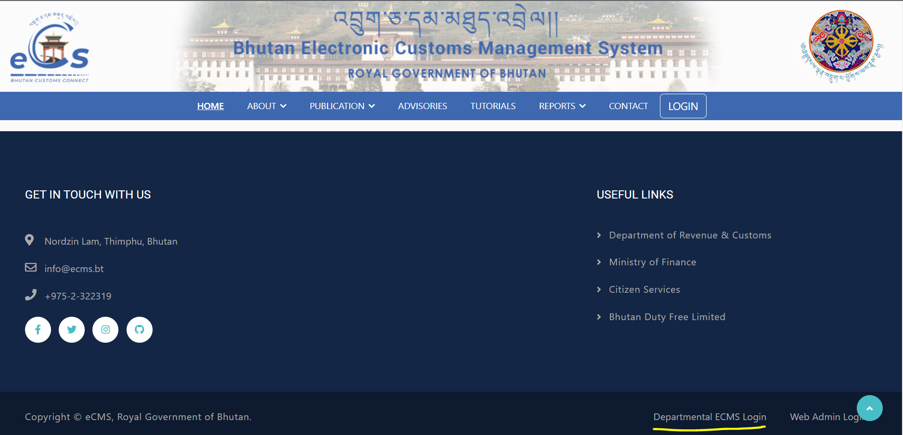

- Click on login menu and provide the required credentials to log in to the system:

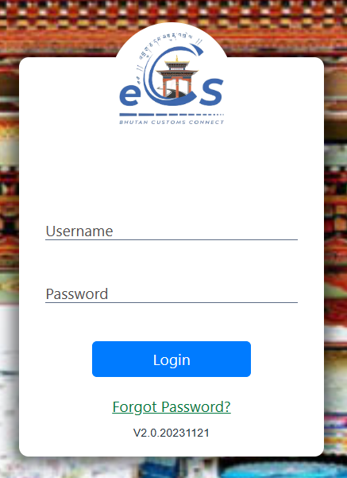

Road Manifest
Transaction of import and export that happens through road required Road Manifest, which needs prior approval from the DRC office.

- Click on the Road Manifest in dashboard.

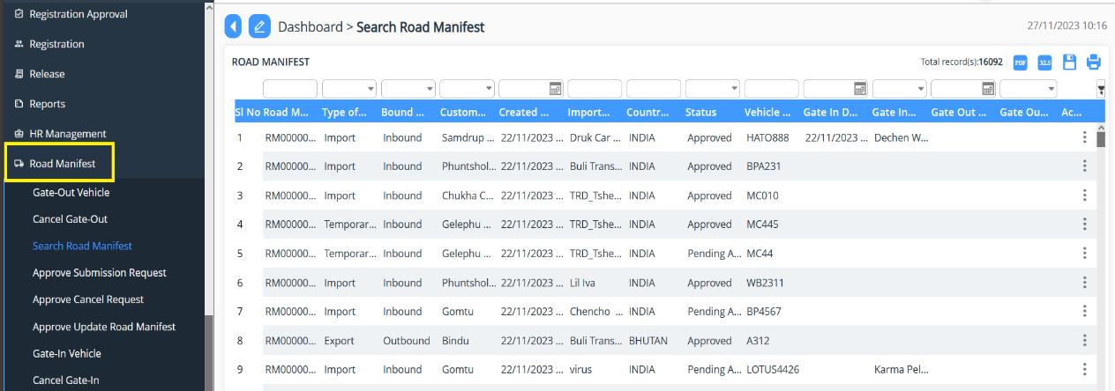

Search Road Manifest

- Provides the list of Road Manifest that has been applied till date.

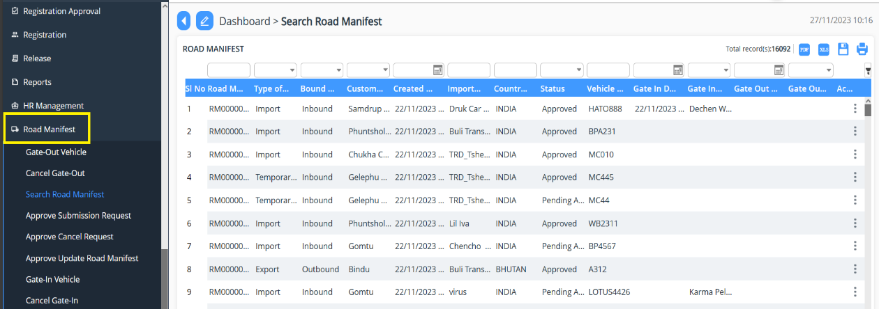

Approve Submitted Request

- Click on “Approve Submission Request”.
- List of application pending shall be shown, then the focal person will be able to act by double clicking on the application or by right-clicking on the on the right and Select Edit
- Status of the application submitted is taken place by selecting the status as:
  - Approve: the application is approved for further process
  - Reject: the application is rejected, and remark is provided for the rejection.
  - Reject for amendment: the application gets rejected for amendment and the applicant can amend the application and resubmit the same application.
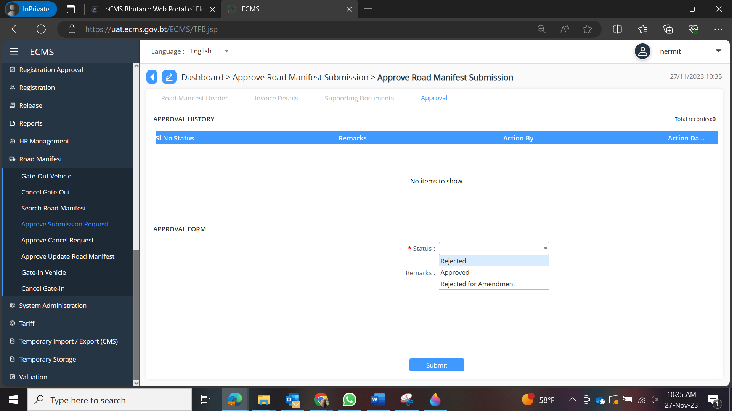

Approve Cancel Request

- Click on “Approve Cancel Request”.
- List of application pending shall be shown, then the focal person will be able to act by double clicking on the application or by right-clicking on the on the right and Select Edit
- Status of the application submitted is taken place by selecting the status as:
  - Road Manifest Cancel Approved: the application is approved for further process.
  - Road Manifest Cancel Rejected: the application is rejected, and remark is provided for the rejection.

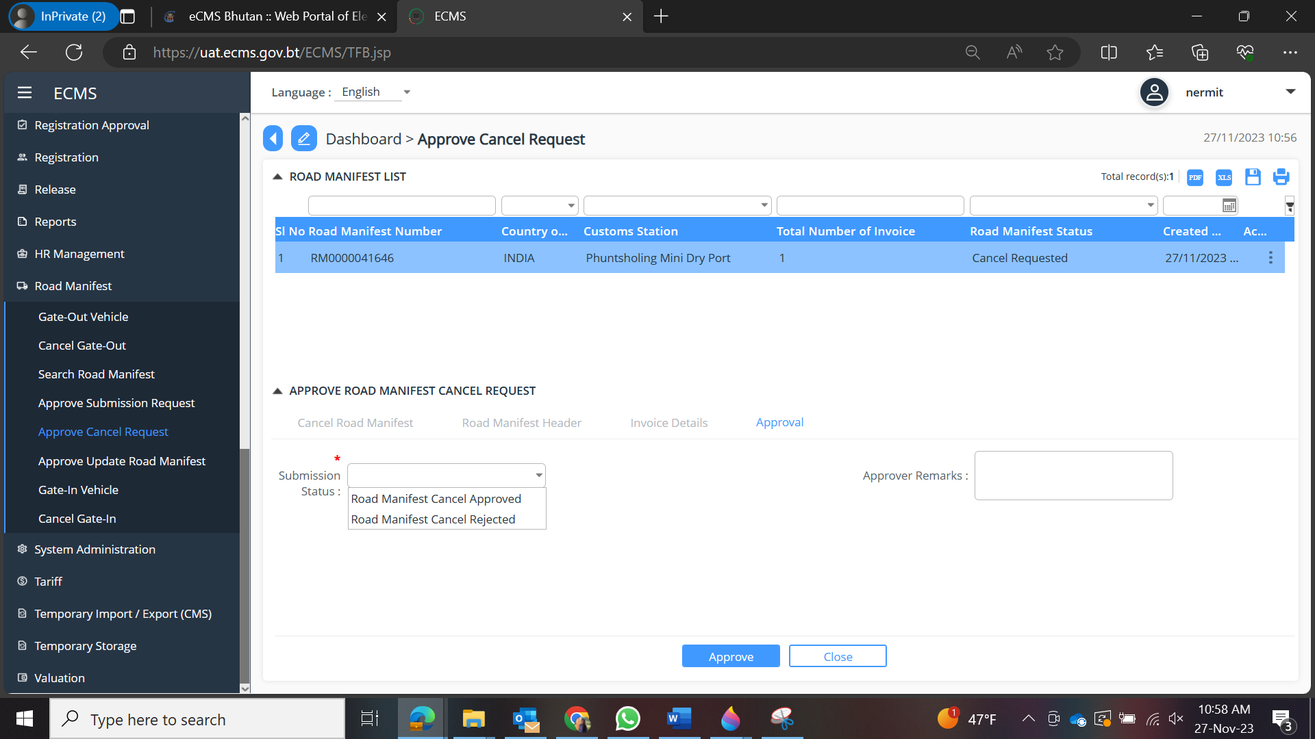

Approve Update Road Manifest

- Click on “Approve Cancel Request”.
- List of application pending shall be shown, then the focal person will be able to act by double clicking on the application or by right-clicking on the on the right and Select Edit
- Status of the application submitted is taken place by selecting the status as:
  - Approve: the application is approved for further process
  - Reject: the application is rejected, and remark is provided for the rejection.
  - Reject for amendment: the application gets rejected for amendment and the applicant can amend the application and resubmit the same application.

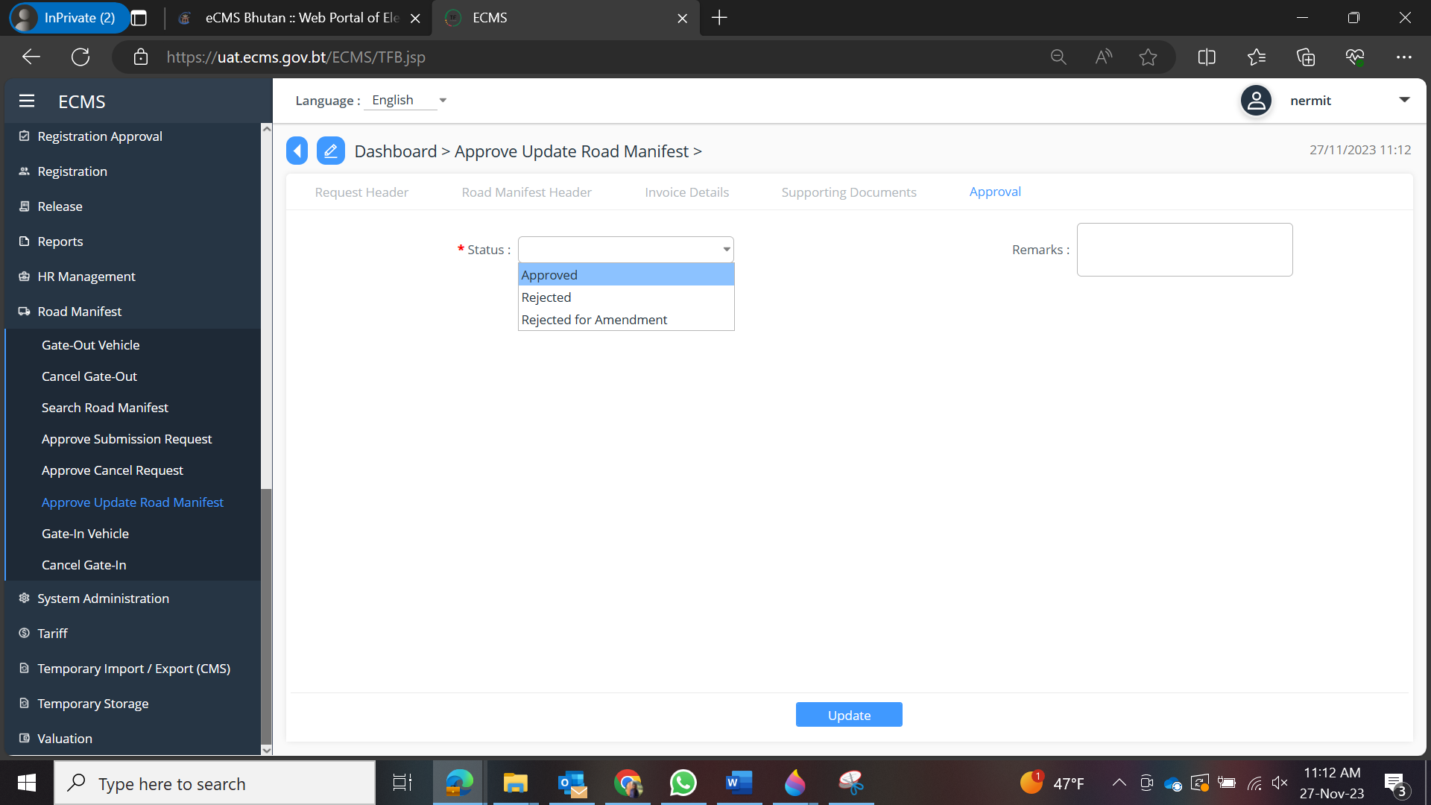

Gate-In Vehicle
The vehicle associated with Road Manifest needs to be gated in for import related transaction.
- Click on Gate In vehicle.
- Select the vehicle number that is associated to the Road Manifest
- Click Gate in tab.
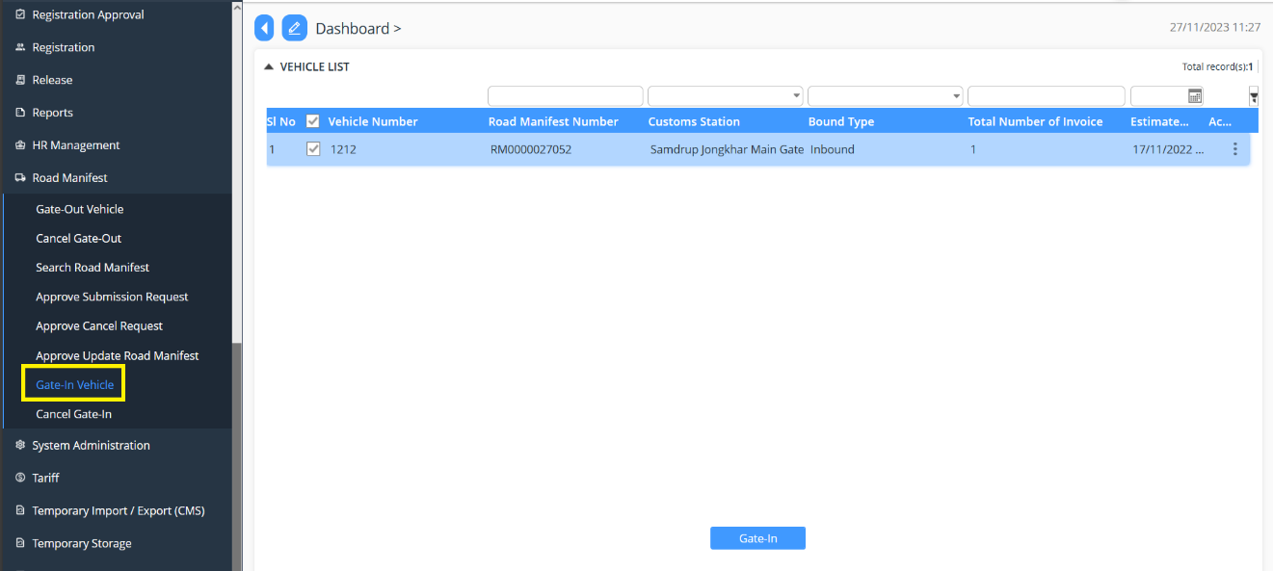

Cancel Gate-in
The vehicle associated can be cancelled gate-in.
- Click on Cancel Gate-in.
- Select the vehicle number that is associated to the Road Manifest
- Click Cancel Gate in tab.

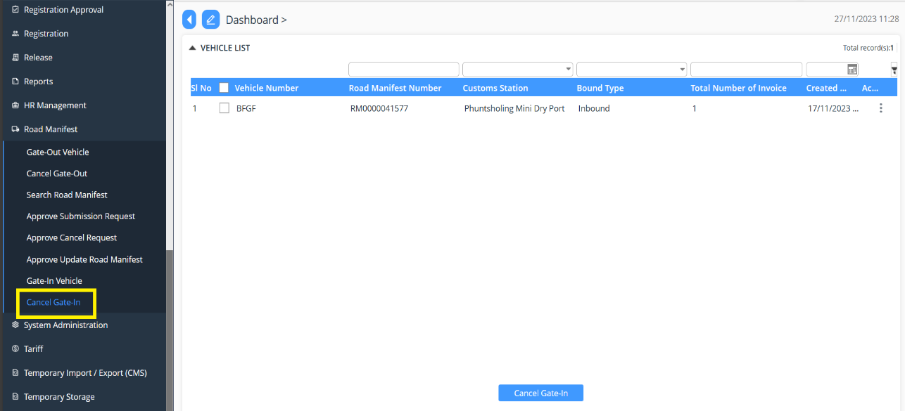

Gate-out vehicle

The vehicle associated with Road Manifest needs to be gated in for export related transaction.
- Click on Gate Out vehicle.
- Select the vehicle number that is associated to the Road Manifest
- Click Gate Out tab.

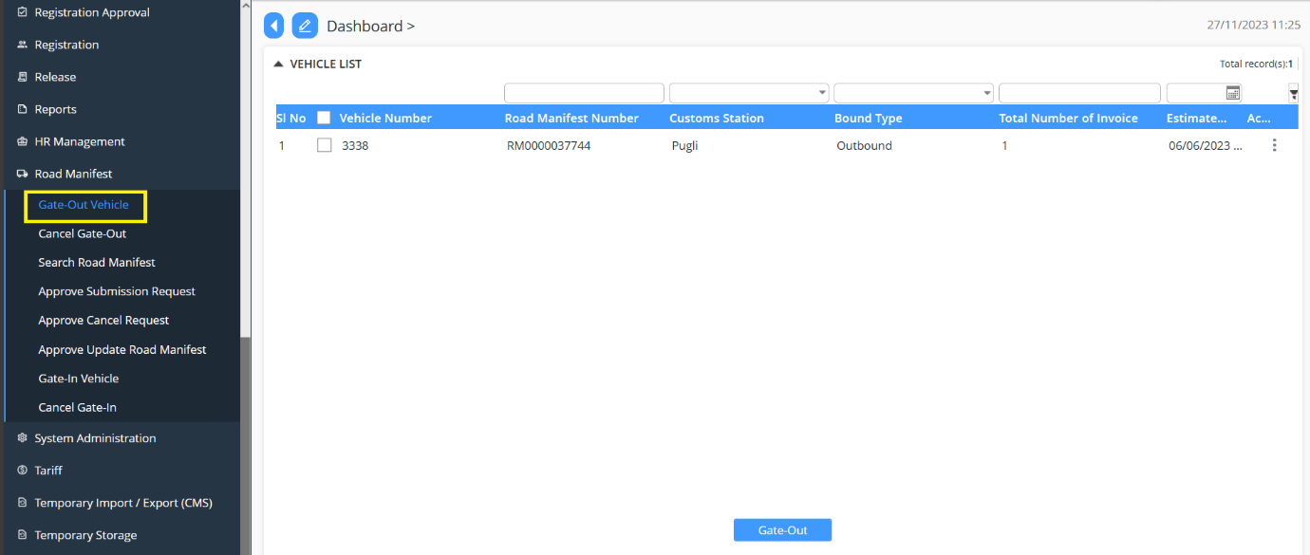

Cancel Gate-Out
The vehicle associated can be cancelled gate-out.
- Click on Cancel Gate-Out.
- Select the vehicle number that is associated to the Road Manifest
- Click Cancel Gate in tab
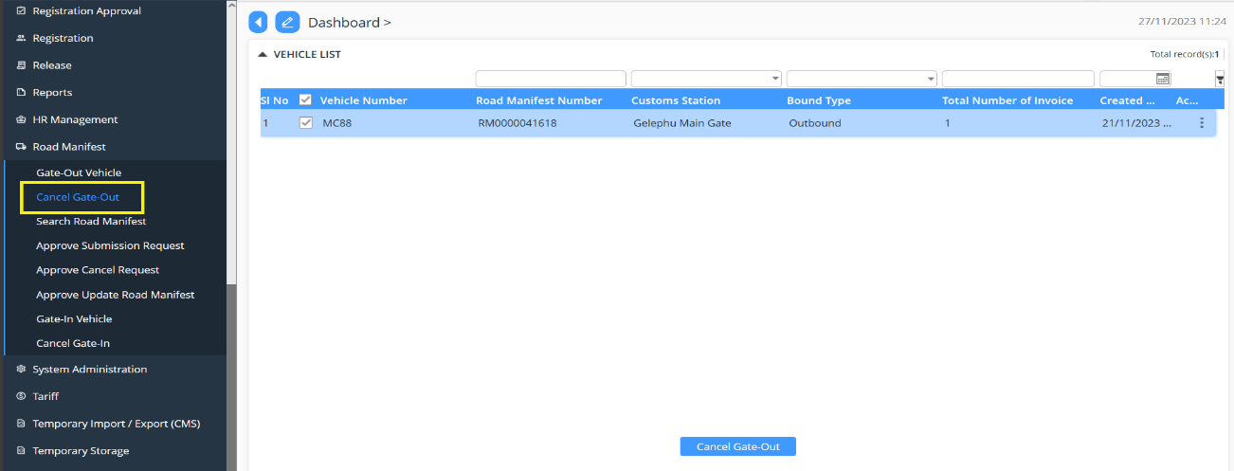

Passenger Manifest
- Click on the Passenger Manifest in dashboard.

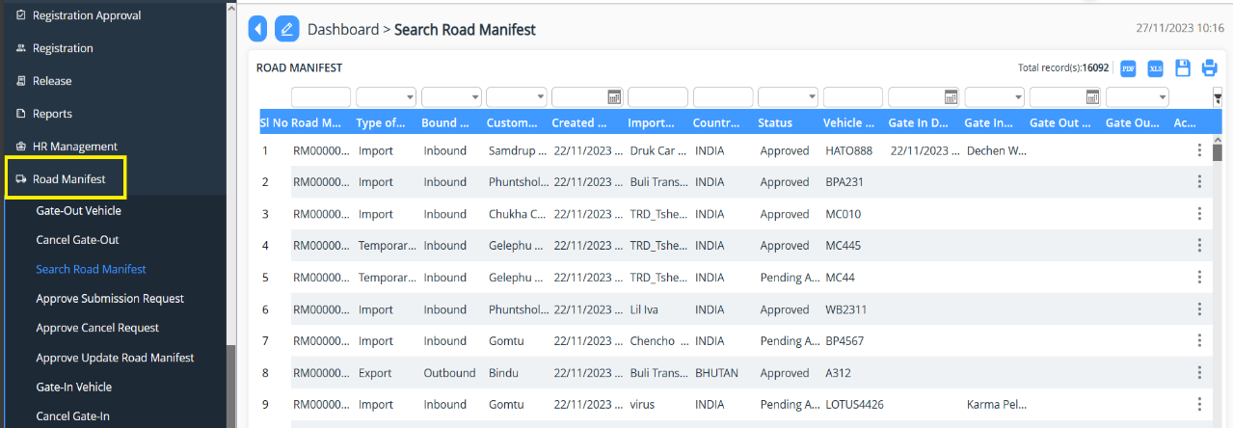

Search Updated Passenger Manifest
- Provides the list of updates made for Passenger Manifest that has been applied till date.\

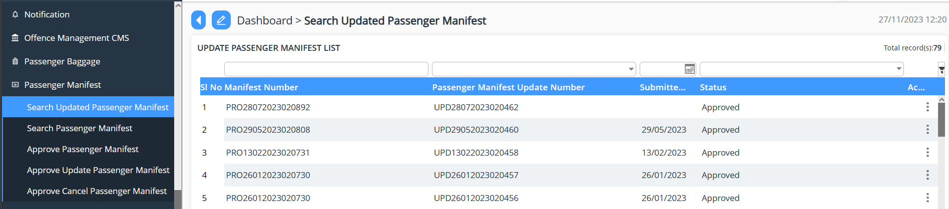

Search Passenger Manifest

- Provides the list of Passenger Manifest that has been applied till date.

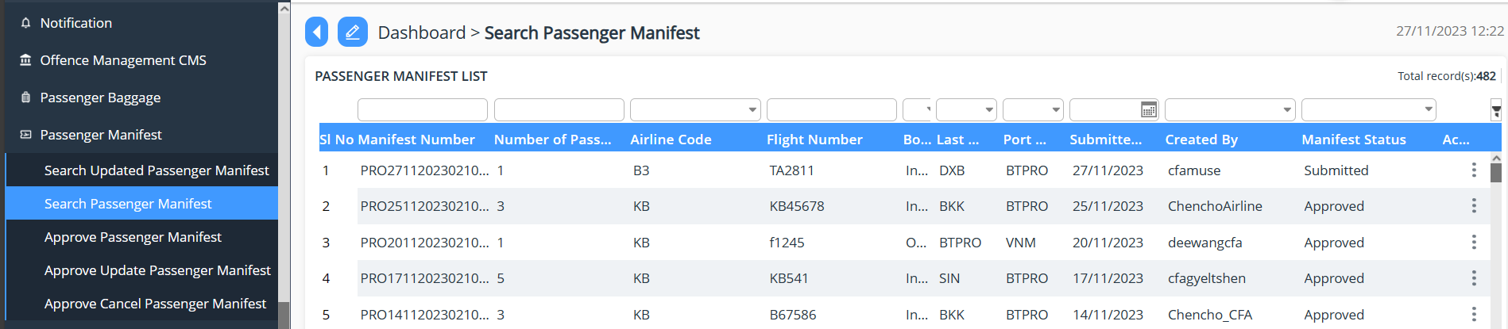

Approve Passenger Manifest

- Click on “Approve Passenger Manifest”.
- List of application pending shall be shown, then the focal person will be able to act by double clicking on the application or by right-clicking on the on the right and Select Edit
- Status of the application submitted is taken place by selecting the status as:
  - Approve: the application is approved for further process
  - Reject: the application is rejected, and remark is provided for the rejection.
  - Reject for amendment: the application gets rejected for amendment and the applicant can amend the application and resubmit the same application.

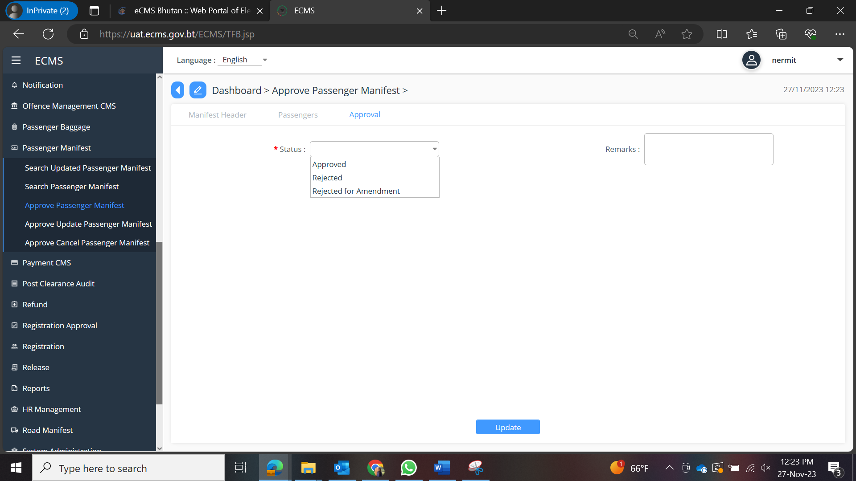

Approve Update Passenger Manifest

- Click on “Approve Update Passenger Manifest”.
- List of application pending shall be shown, then the focal person will be able to act by double clicking on the application or by right-clicking on the on the right and Select Edit
- Status of the application submitted is taken place by selecting the status as:
  - Approve: the application is approved for further process
  - Reject: the application is rejected, and remark is provided for the rejection.
  - Reject for amendment: the application gets rejected for amendment and the applicant can amend the application and resubmit the same application.

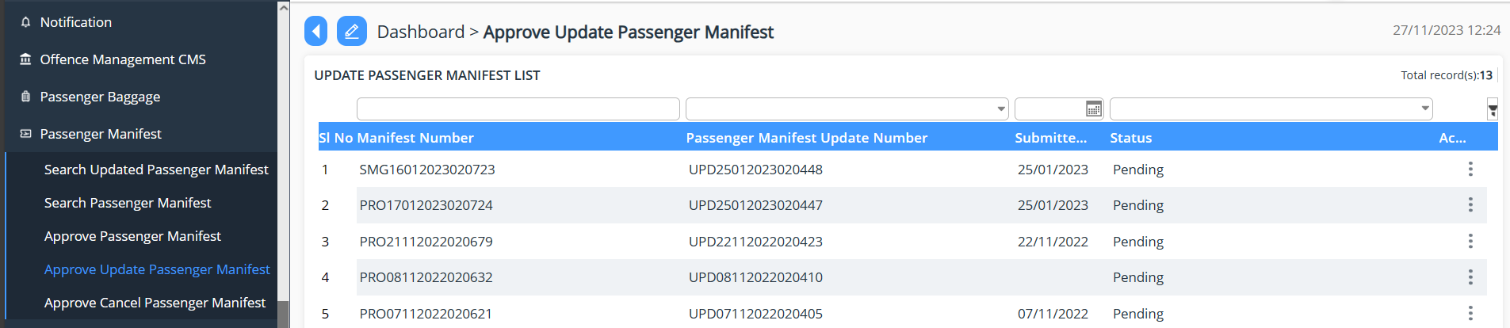

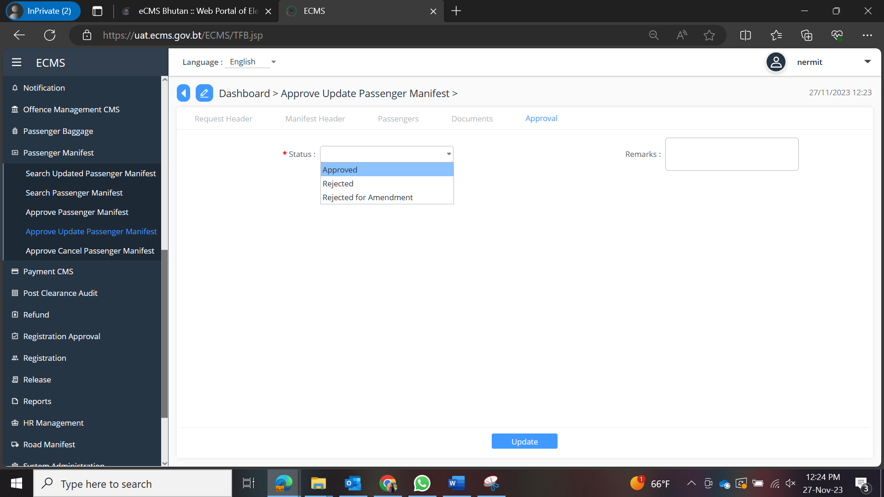

Approve Cancel Passenger Manifest

- Click on “Approve Cancel Passenger Manifest”.
- List of application pending shall be shown, then the focal person will be able to act by double clicking on the application or by right-clicking on the on the right and Select Edit
- Status of the application submitted is taken place by selecting the status as:
  - Approved: the application is approved for further process.
  - Rejected: the application is rejected, and remark is provided for the rejection.

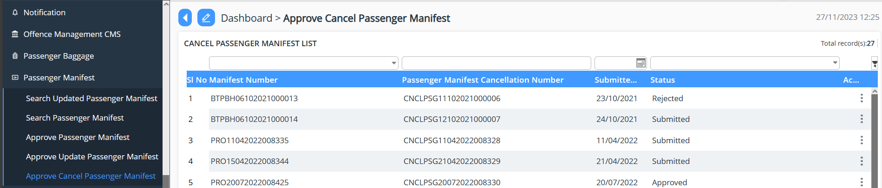

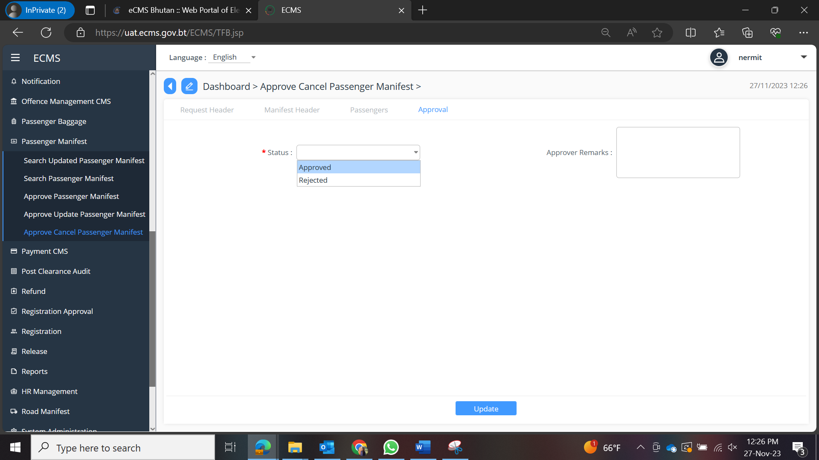

Air Cargo Manifest
- Click on the Air Cargo Manifest in dashboard.

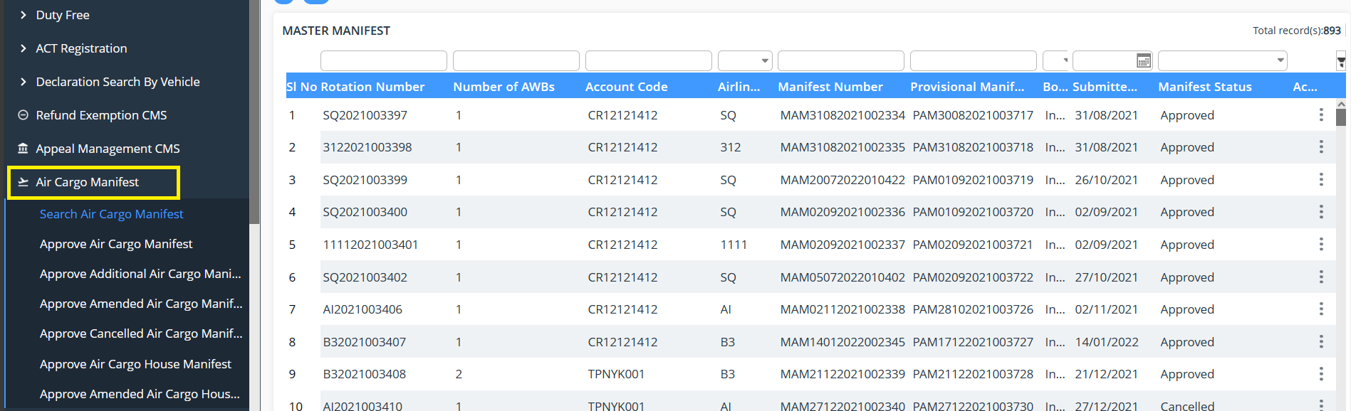

Search Air Cargo Manifest
- Provides the list of Manifest that has been applied till date.

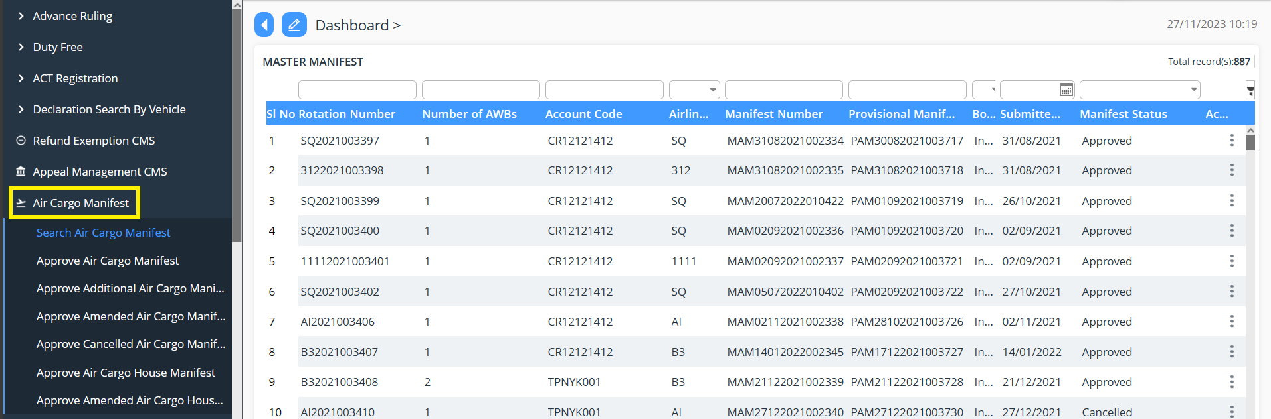

Approve Air Cargo Manifest

- Click on “Approve Air Cargo Manifest”.
- List of application pending shall be shown, then the focal person will be able to act by double clicking on the application or by right-clicking on the on the right and Select Edit
- Status of the application submitted is taken place by selecting the status as:
  - Approve: the application is approved for further process
  - Reject: the application is rejected, and remark is provided for the rejection.
  - Reject for amendment: the application gets rejected for amendment and the applicant can amend the application and resubmit the same application.

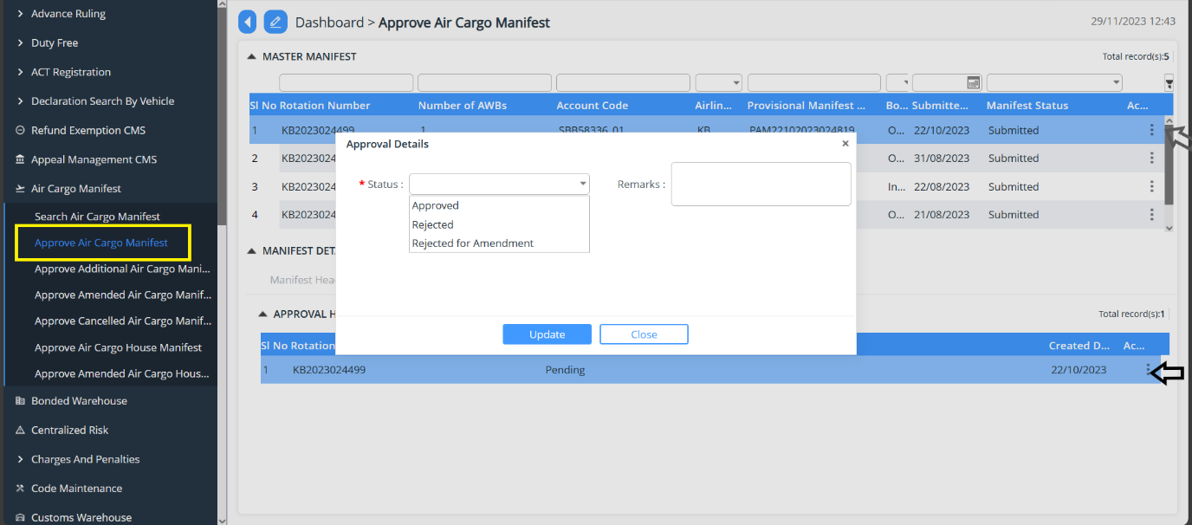

Approve Additional Air Cargo Manifest

- Click on “Approve Additional Air Cargo Manifest”.
- List of application pending shall be shown, then the focal person will be able to act by double clicking on the application or by right-clicking on the on the right and Select Edit
- Status of the application submitted is taken place by selecting the status as:
  - Yes: the application is approved for further process
  - No: the application is rejected, and remark is provided for the rejection.
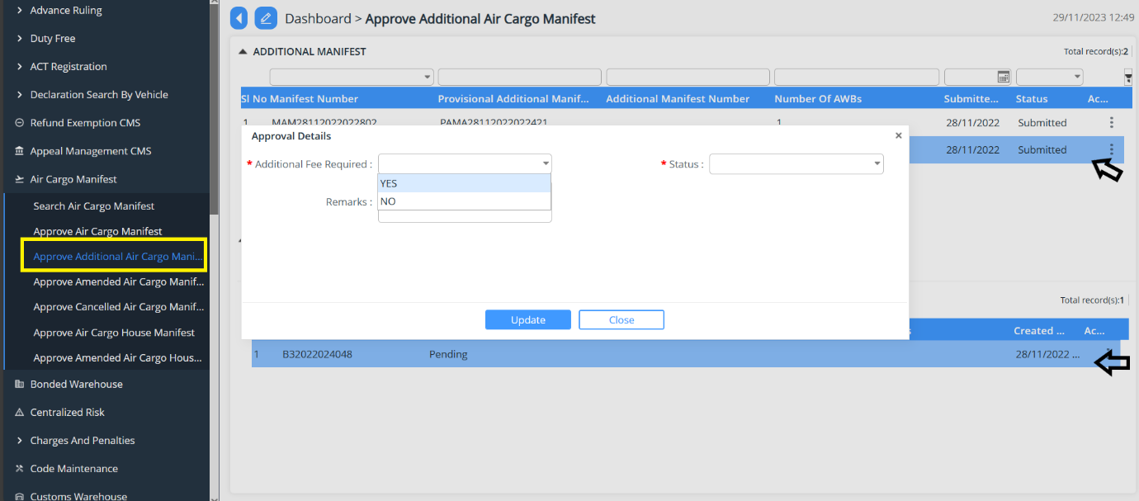

Approve Amended Air Cargo Manifest

- Click on “Approve Amended Air Cargo Manifest”.
- List of application pending shall be shown, then the focal person will be able to act by double clicking on the application or by right-clicking on the on the right and Select Edit
- Status of the application submitted is taken place by selecting the status as:
  - Approve: the application is approved for further process
  - Reject: the application is rejected, and remark is provided for the rejection.
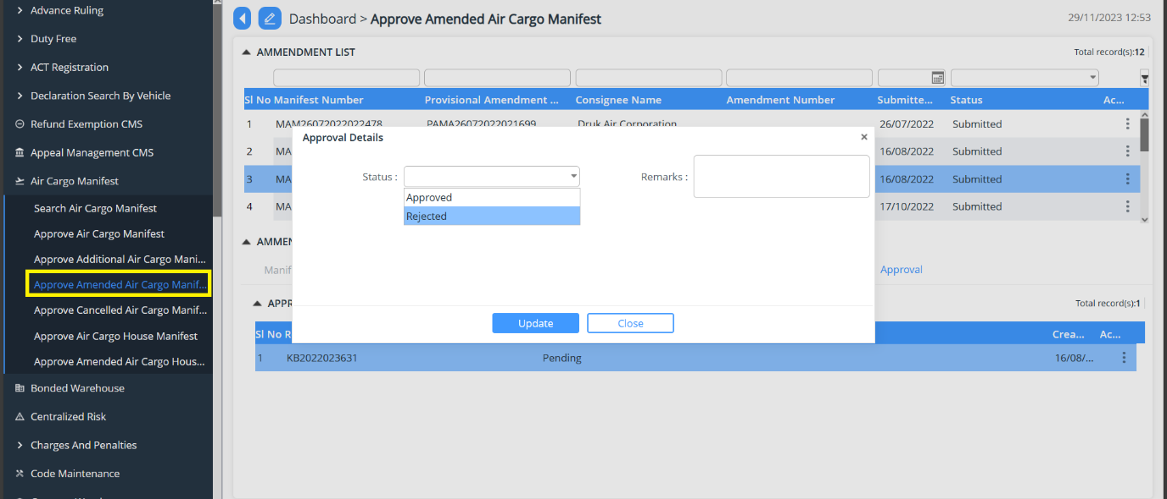

Approve Cancel Air Cargo Manifest

- Click on “Approve Cancel Air Cargo Manifest”.
- List of application pending shall be shown, then the focal person will be able to act by double clicking on the application or by right-clicking on the on the right and Select Edit
- Status of the application submitted is taken place by selecting the status as:
  - Approve: the application is approved for further process
  - Reject: the application is rejected, and remark is provided for the rejection.
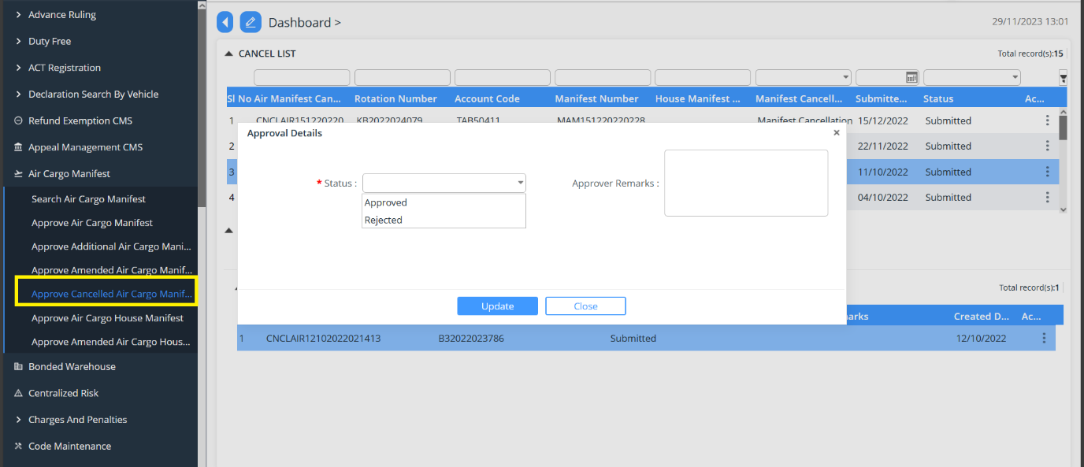

Approve Air Cargo House Manifest

- Click on “Approve Air Cargo House Manifest”.
- List of application pending shall be shown, then the focal person will be able to act by double clicking on the application or by right-clicking on the on the right and Select Edit
- Status of the application submitted is taken place by selecting the status as:
  - Approved: the application is approved for further process.
  - Rejected: the application is rejected, and remark is provided for the rejection.

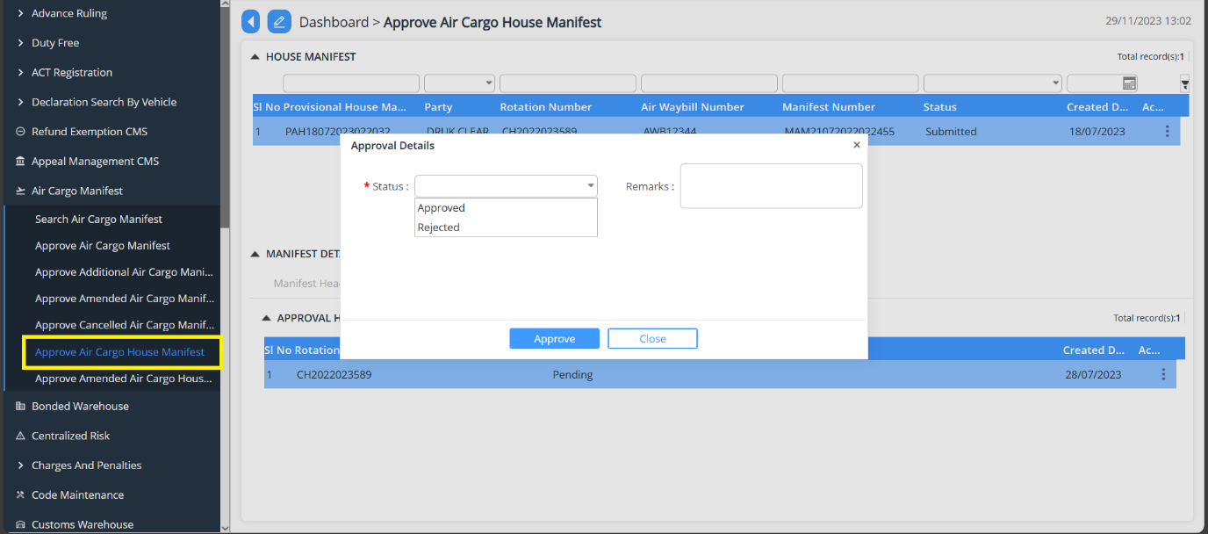

Approve Amend Air Cargo House Manifest

- Click on “Approve Amend Air Cargo House Manifest”.
- List of application pending shall be shown, then the focal person will be able to act by double clicking on the application or by right-clicking on the on the right and Select Edit
- Status of the application submitted is taken place by selecting the status as:
  - Approved: the application is approved for further process.
  - Rejected: the application is rejected, and remark is provided for the rejection.
  - Rejected for Amendment: the application gets rejected for amendment and the applicant can amend the application and resubmit the same application

